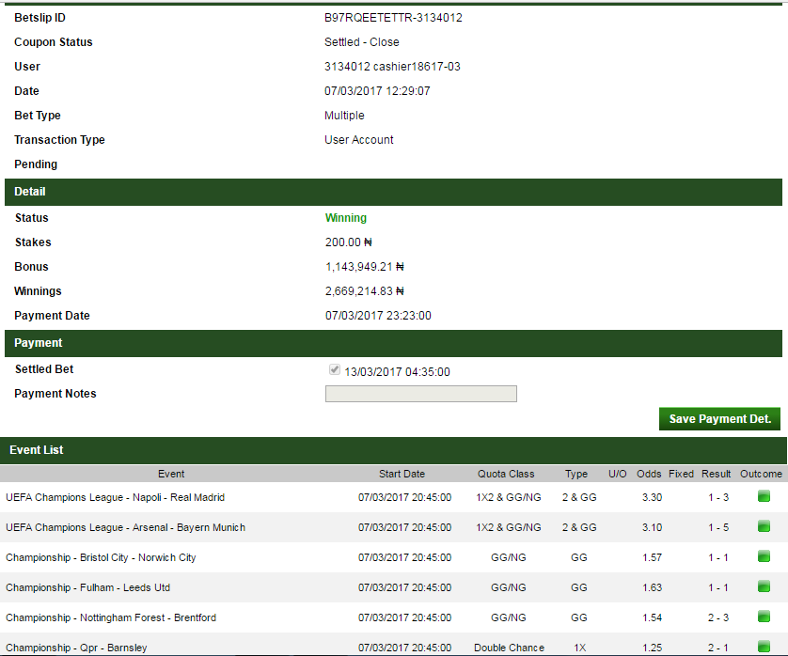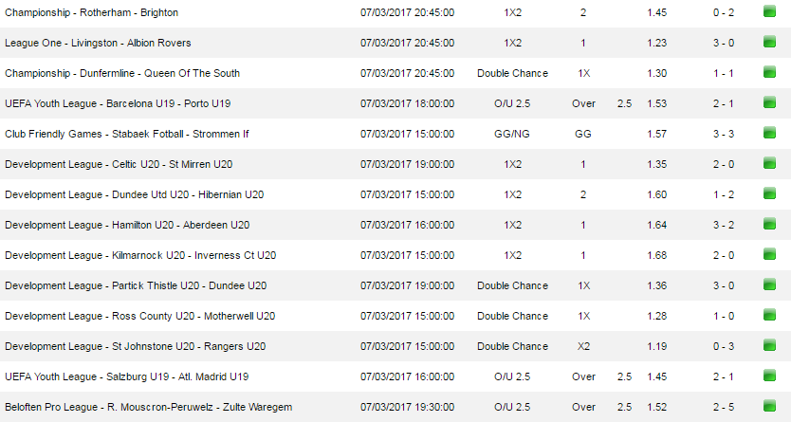
It Can Be Your Turn Today!!!!!!!!!!
Just A Trial Will Convince YOU!!!!
BEST WISHES……….
PAID
BET9JA…… REWARD FOR PASSION
MEGA WINNING……….. WITH JUST A TOKEN, YOU CAN BE A MILLIONAIRE!!!!!!!!!!

SETTLED

